**1 Augsut, 2024 v2.4**

**Draft SensorCAM Manual**

**CONTENTS**

1. **Overview 1**
2. **ESP32-CAM 3**
3. **Physical Installation 5**
4. **Notation & Help commands 7**
5. **Configuration 8**
6. **PROCESSING4 monitor/console 11**
7. **Wiring Requirements 13**
8. **Communication and Host Operation 14**
9. **Methodology of operation 15**

**Appendix**

1. **ESP32 sensorCAM Command Summary 17**
2. **Check List for Optimising Sensor Resonse 19**
3. **I2C sensorCAM commands & PROTOCOL. 20**
4. **I2C DCC-EX CS IO_EXIOExpander commands & PROTOCOL. 21**
5. **Tabulation of Recommended DCC-EX-CS id’s for sensorCAM 23**
6. **Hardware Notes. (including PCA9515A) 24**
7. **Filtered DCC EX-CS commands 25**
8. **Configuring EX-CS to connect to sensorCAM as an EXIOExpander. 26**
9. **Overview**

The sensorCAM is a video camera replacement for physical proximity sensors/detectors on a model railroad. It can replace up to 80 detectors and their associated power and signal wiring using artificial vision alone. It offers the flexibility of sensor placement or relocation instantly by software command with no physical layout modification. The railroad can be automated using artificial vision of train activity. Each virtual sensor can produce a logical state of 1 (occupied) or 0 (unoccupied) and is readable over an i2c cable. SensorCAM uses the ESP32-CAM module.

The sensorCAM takes 10 frames per second in RGB565 format at QVGA resolution of 240 x 320. Each sensor consists of a square group of 16 pixels which equates to approx. 20x20mm square with the standard lens at 1500mm. The software decodes and saves only the 80 sensor images (1280 pixels) and then compares each sensor image with a reference image prerecorded either at startup, on request, or by a “recent” automatic update. If the images do not match the references well then the sensor is “tripped” or “occupied” & status ‘1’ is produced. Good match results in ‘0’ output. The state of virtual sensors can be manually monitored on the USB monitor, or polled by microcontroller over the i2c interface cable. **N.B.** The sensorCAM is sensing ***only*** *when the Flash LED is pulsing* (for each new frame).

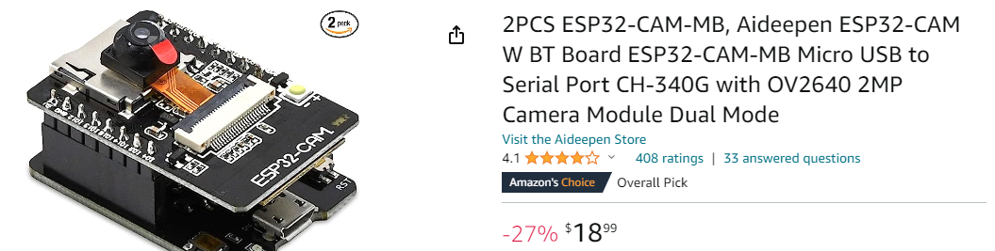

Dealing with video images involves complexities not normally associated with model railroading sensors. The sensorCAM is a complex device with a number of commands explicitly for setup and evaluation. In addition to these, several “output” commands can be used by a host to interrogate the “virtual sensor” output states. The initial setup can be somewhat involved and requires familiarity with most of the 25 commands discussed below.

The sensorCAM has two ***mutually exclusive modes*** of operation; the sensorCAM mode and the webCAM mode. The webCAM mode is essentially as described in the on-line tutorials. Use that mode only for education and curiosity. Invoke webCAM video mode by issuing the v (or v2) sensorCAM instruction to get a webCAM URL (e.g. 192.168.0.*64*)

The ESP32-CAM does not have a USB port so you will need an FTDI interface or MB. I prefer to use the ESP32-CAM-MB (MotherBoard) interface which plugs directly behind the CAM. Check “The Workshop” You tube videos on-line for guidance. The MB is simpler to use (needing no jumpers or cables) than a separate FTDI used in the videos.

The ESPRESSIF guide will show how to install the Arduino-ESP32 support. BE WARNED: using an FTDI (rather than MB) that has a jumper set to 5V and connecting it to the CAM 3V3 pin will destroy the ESP32-CAM. Many have died.

[Installing — Arduino-ESP32 2.0.6 documentation (readthedocs-hosted.com)](https://espressif-docs.readthedocs-hosted.com/projects/arduino-esp32/en/latest/installing.html#installing-using-arduino-ide)

https://espressif-docs.readthedocs-hosted.com/projects/arduino-esp32/en/latest/installing.html#installing-using-arduino-ide

A tutorial on setting up the ESP32 on Arduino IDE is available at:

[ESP32 CAM - 10 Dollar Camera for IoT Projects - YouTube](https://www.youtube.com/watch?v=visj0KE5VtY)

https://www.bing.com/videos/search?q=ESP32+CAM+-+10+Dollar+Camera+for+IoT+Projects+-+YouTube&view=detail&mid=77BF6363644D71DF685B77BF6363644D71DF685B&FORM=VIRE

[Introduction to ESP32 - Getting Started - YouTube](https://www.youtube.com/watch?v=xPlN_Tk3VLQ)

<https://www.youtube.com/watch?v=xPlN_Tk3VLQ>

The sensorCAM software is uploaded to the ESP32-CAM using the Arduino IDE. The sensorCAM has been programmed with two modes of operation; a webCAM mode (as in the on-line tutorial) and a sensorCAM mode. The limited power of an ESP32 prevents both functioning at the same time. Consequently, to see an image of the railway while sensorCAM is operational requires a third application (Processing 4.2) to retrieve a still image from the CAM over the USB cable to a computer. The Processing 4 .pde app replaces the Arduino IDE and IDE monitor retaining the sensorCAM command set and offering a (slow) image capture capability. Processing 4 allows virtual sensors to be placed on an image of the railway with a simple mouse click.

In addition to the FTDI interface, you will most likely need a daughter board “carrier” or prototyping board to connect to the real world (power, indicators, control wires, and i2c.) Further details are given below. However to test the sensorCAM functions, one only needs the CAM and FTDI modules with power from the USB port.

To control a railway, the railway needs a microcontroller based management system. This typically could be an Arduino Mega based system running software such as the DCC-EX CommandStation and EX-RAIL automation application. Alternatively a dedicated sensorCAM microcontroller based interface could be connected to the i2c bus for output on multiple parallel sensor pins as per a more conventional low sensor count sensing device. The EX Command Station (CS) solution requires the addition of sensorCAM specific code (sketches) as detailed later.

1. **ESP32-CAM**

The heart of the sensorCAM is the ESP32-CAM module containing an ov2640 camera sensor and a 32bit ESP32-S microprocessor. The sensorCAM software/sketch is loaded into the ESP32 using the Arduino IDE over a USB port with settings newline/115200 Baud. Follow the above guidelines and run the camera example first, to get a demo webserver and CAM operational with a simple coloured test image. Experiment with settings to “get a feel” for the parameter effects which need optimization. The CAM has a considerable number of video related on-screen settings.

Figure 1. 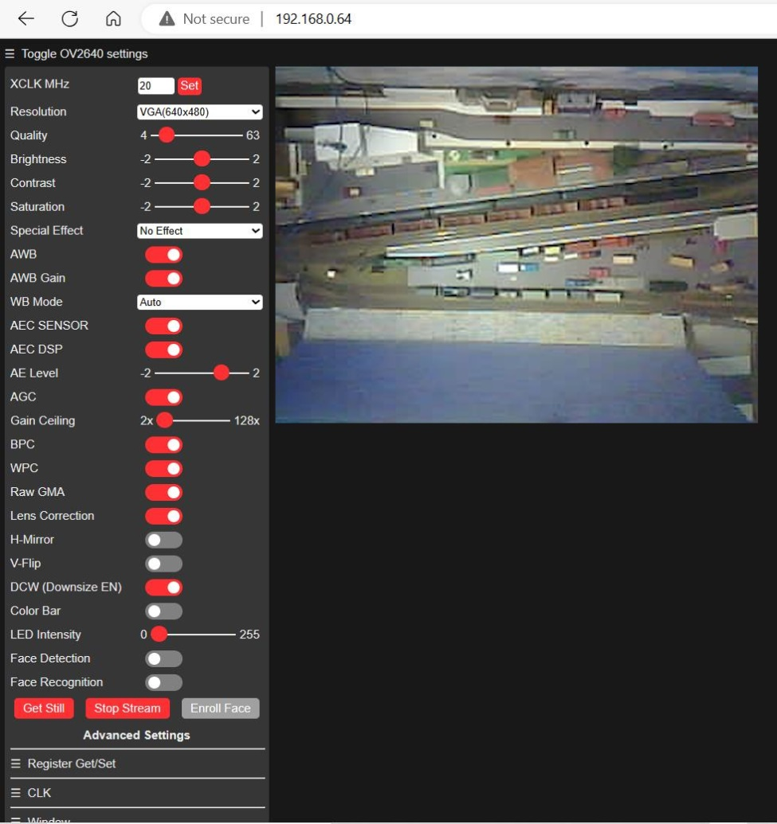 webCAM

Figure 1. is an example of the standard webCAM browser presentation. It is usable as a training aid in investigating the effects of the many video adjustments possible, but does not allow placement of sensors as sensorCAM mode can’t be simultaneously enabled.

Brightness, Contrast, Saturation, AutoWhiteBalance(AWB), AWBgain, AutomaticExposureCtl(AEC), AECdsp, AELevel, AutomaticGainCtl(AGC), AGGainCeiling and more can be adjusted. The QVGA startup settings of sensorCAM are:

*Bri*=0, *Con*=1, *Sat*=2, *AWB*=1, *AWBg*=1, *AEC*=1, *AECd*=1, *AEL*=1, *AGC*=1, *AGg*=9; (initial settings of 'c' parameters)

These can be changed after the CAM images are stable. C++ variables *AWB9* and *AGC9* may be set to 0 after 9 seconds in code (ver158+ has them staying as ‘1’). Find them and reset to 0 in the *sensorCAM.ino* file if required.

If you “Start Stream”, parameter changes will seem almost immediate. But with “stills”, after changing a variable, you may have to click “Get Still” 3 times to clear the pipeline and get a changed image. In Stream mode, close observation will reveal changing whole image brightness/colour for several seconds after image disturbance (e.g. a hand in front of CAM) as the auto adjustments “correct” the image. These types of changes can trip the sensorCAM even if the obstruction does not block the virtual sensor. Consequently after power-up, the sensorCAM may stabilize and then turn off some auto adjustments in the first 15 seconds. Changing environment lighting may result in a need to use a “recalibrate” command, for example perhaps after sunset or turning on extra lighting.

Due to the slowness of the ESP32, the “live stream” is slow and a webCAM delay in response will be observed. This may be a little quicker for sensorCAM mode. It is inherent in webCAM mode.

Figure 2 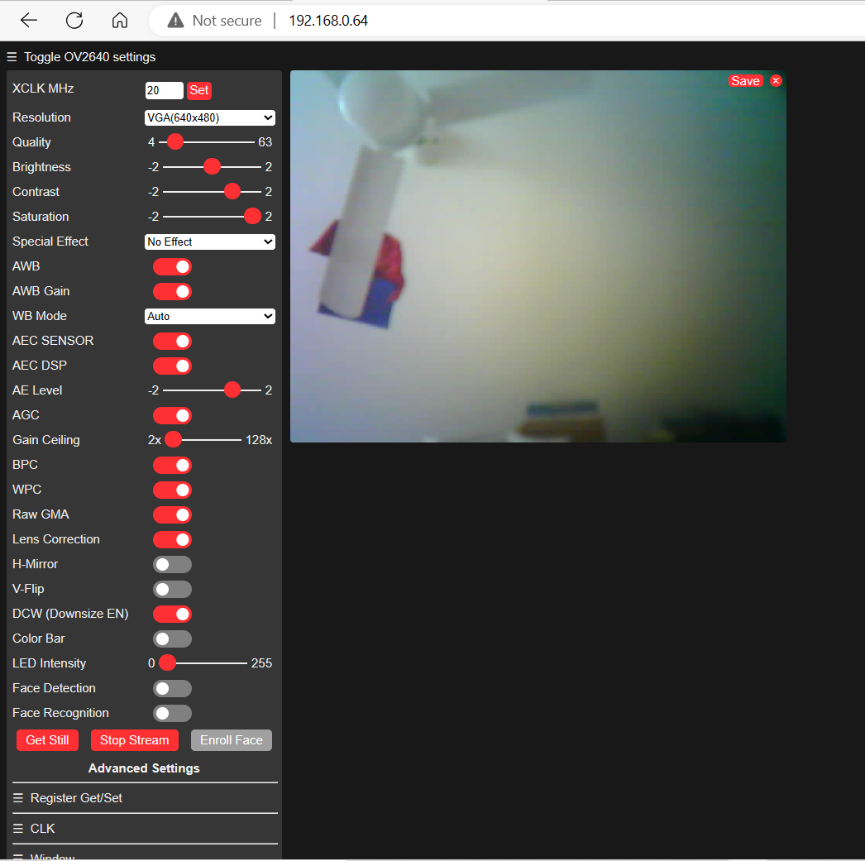 Initial sensorCAM settings

After the sensorCAM has booted up, it reads frames for 9 seconds before automatically doing a reference grab for all defined sensors (the **r00** command) . ver168 by default sets the CAM configuration to those below. When sensorCAM is running, a user may tweak these settings via a USB monitor ‘c’ or ‘j’ commands if required.

*Bri*=0, *Con*=1*, Sat=*2, *AWB*=1, *AWBg*=1, *AEC*=1, *AECd*=1, *AEL*=1, *AGC*=1, *AGg*=9; (initial settings of 'c' parameters)

The ESP32-CAM has an Infra-Red (IR) filter to enhance colour response. The sensorCAM relies on strong colour contrast (saturation) to detect changes. Low lighting levels and poor contrast degrades performance.

To run the sensorCAM.ino, it will be necessary to configure the Arduino IDE for the ESP32 as covered in the above you-tube tutorial links. Load and run the demonstration. For the sensorCAM, you will require new files in a directory such as Arduino/sensorCAM as shown below. Create and edit configCAM.h from the example. The ESP32-CAM uses the “AI Thinker ESP32-CAM” found under Tools:Board:ESP32-Arduino. Check the correct Port is selected, compile sensorCAM.ino, and upload to the CAM before opening the Arduino monitor.

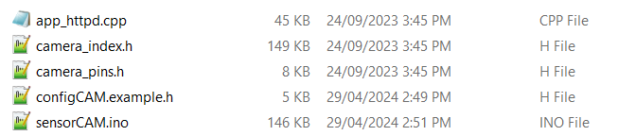

The ESP32-CAM can take rgb565 frames at 13/second. However it is a 3 step process; image sensing, processing and storing. It will then take further cycles to assess the state of the 80 virtual sensors in the frame (another two cycles) A total of 5 cycles places a significant limit on the sensorCAM speed of response time (up to 0.5 seconds at 10 frames/second). A fast HO loco can travel 160mm @100kph, so this latency might need to be accommodated in planning virtual sensor locations.

1. **Physical Installation**

For testing purposes you will need a computer with a spare USB port and the Arduino IDE software installed. The PROCESSING 4 software is also advisable as it gives a more reliable image for setup. A long powered USB cable (5m?) may be an advantage as the sensorCAM may be some distance from the PC. For a final installation the sensorCAM would be connected via a cat5/6 cable carrying power and an i2c bus (of up to 30m) to a microcontroller, Command Station or similar.

For a test hookup between a USB powered sensorCAM and a Command Station with a short existing i2c bus, provided the total length is under say 3 metres, a simple arrangement could be tried using a PCA9515a buffer and level shifter. It requires soldering 5 wires to the underside of the MB USB interface. *This improvisation is* *not an ideal “universal” arrangement*. The PCA9515A is mounted on 1/16” thick double-sided adhesive foam mounting tape. The CAM on i2c bus is best used theoretically with the USB computer running on battery power alone (unplugged) to absolutely avoid ground loops and associated electrical noise, but will probably function OK anyway. 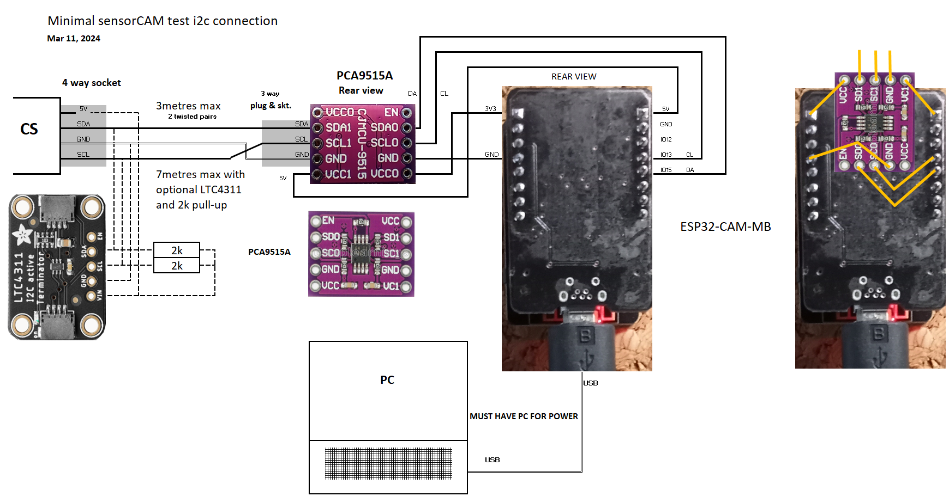

**Figure 3 CAM with 3.3 to 5V i2c interface and optional “terminator”**

The sensorCAM is preferably placed above and square-on to a section of layout at a height of 1 to 1.8m above the surface. 1.2m gives a max. coverage of approximately 1.2 x 0.9m with the standard lens. Another arrangement with several advantages is to place the CAM near the surface so as to view the surface via some good mirror tiles placed on the ceiling, positioned to ensure coverage of the desired sensor locations. This may increase coverage, especially if multiple mirrors are at slight angles. The mirror arrangement with benchtop level mount allows for wider coverage with low ceilings, and also places the CAM in a more accessible spot for wiring and maintenance. Mirror tiles do not need to be perfectly flat, some image distortion is acceptable but they must be stable. A side-on camera angle may also be used to advantage, but sensor location and tripping point may be compromised somewhat.

Lighting is critical for reliable operation. Theoretically, the lighting should be steady. Both LED flood and Fluorescent lighting might degrade results due to the flickering levels of illumination at 100/120 Hz. Use quality LED lights. The light fittings should not be visible in the camera’s field of view. A uniform level of lighting is the objective, with a minimum influence from fluctuating daylight, fans and cloud shadows through windows. Some experimentation may be needed to avoid local “glare”. Images may show white test panels to have several drifting horizontal dull bands produced between cycles of the mains supply (Figure 4). Bright lighting is desirable (good quality LEDS?) to enhance colour differentiation. Check for flicker by taking a “slo-mo” video on a cell phone. Fluoro’s are bad!

The mount needs to be rigid to avoid vibration which can trip sensors due to small image movements. It also needs to have a suitable route for a (cat5) cable for its own power supply and the necessary i2c communications. The length of this cable needs to be considered if the railway’s i2c network is otherwise long. The prototype CAM has been fitted with i2c buffers and used on a 20m buffered 5 Volt i2c Cat5 bus, but the quick connection above (using PCA9515A) is for short lengths only (i2c under 3m). Up to 7m may be achieved using 2k pull-up resistance and one LTC4311 “terminator” to enhance signal rise time. Benchtop mounting with mirrors minimizes this length issue.

Most reliable results may be obtained with light grey coloured ballast and dark sleepers. If results are inadequate, light green (grass?) or yellow “reflectors” between the rails may relieve the problem. (recommended in fiddle yards) If lighting throws shadows beside rolling stock, the shadows can be used advantageously by good sensor placement.

For initial configuration, access to the sensorCAM’s USB port is important. Loading computer code over a long USB cable is problematic, but monitoring and tweaking settings may be done with a reduced BAUD rate or a (5m?) buffered USB cable at 115200 BAUD. A benchtop mounting with mirror helps here.

With regards lighting, fluoroescent or LED lighting normally flickers at twice mains frequency so it pulses at 100 or 120Hz. This is normally tolerable, but it can be seen in a sensorCAM image on a uniformly white test panel as below (Figure 5). In 100mSec there could be up to 10 bands in one image. SensorCAM tries to synchronise with the mains frequency, but if it fails the faint bands will drift across the sensors and potentially trip them in the worst case scenario. Set the threshold high enough to avoid such trips. Figure 4 shows an example of bad 100Hz banding.

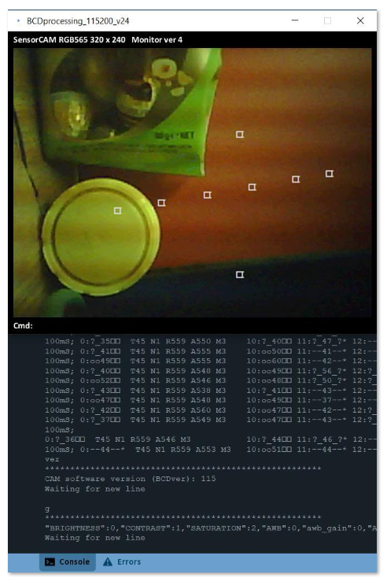

**Figure 4 Test image showing fluorescent or LED light banding.**

**4. Notation & Help commands**

**4.1 Notation**

The notation used in the reference material uses symbols according to the following convention:

% used to designate a digit as part of a bank/sensor designator in bsNo style. i.e. 0/2, b/s or %/% or %%

# used to designate a digit as part of a decimal number as in ### for a 3 digit decimal number.

$ used to designate a single alphanumeric character (0-9 or A-Z) depending on context.

S Capital S may be used to refer to a specific sensor such as S02 for example. Designation format: S%%

[ ] Square brackets may be used to indicate optional command arguments (don’t include [ ] in command).

Sensor ‘bsNo.” number consists of two digits preferably written separated by a ‘/’ as in 1/2 but in commands this is reduced to 12 as in command i12. Command ‘i’ has the form i%% indicating it requires a 2-digit bsNo. As 49 is an invalid bsNo. (s range is 0-7), i49 is invalid. Some commands require a DECIMAL number and are expressed as having form t## for example. t49 is therefore a valid command. The ‘m’ command takes the form “m$,##” requiring a single digit and a 2-digit decimal number. For more details on commands see APPENDIX A.

Where bsNo.’s are printed, they can take several equivalent forms depending on context. Where possible they are printed as %/% e.g. 2/3. However an equivalent form is 023. Any printed sensor number starting with a ‘0’ can be treated as equivalent to the ‘/’ form so 023 == 2/3 == bank 2 sensor 3. The 0%% form is in fact the “OCTAL” format of bsNo. (Note: OCTAL for 8/7 is 0107 & 9/5 = 0115. Keeping usage to banks ranging from 0 to 7 avoids any confusion).

Some diagnostic output (eg ‘f%%’) may resort to another numbering system (i.e. HEXADECIMAL) for compactness, but for normal usage, this notation can generally be avoided. Just be aware of the context in which numbers are being used.

Where words are in *italics*, these are the actual names used in the C++ programs for sensorCAM. Consequently they may seem cryptic, but their function is hopefully clear. **NOTE:** They may use “active” and “enabled” interchangeably.

**4.2 Help commands**

As the sensorCAM is still under development, the sketch still has numerous debugging options and a couple may be useful in understanding and optimizing the device. The help command has the form ‘h#’ where the digit # turns ON a debug output. The following h# output options might be useful, **particularly h7, i.e. a triggered wait (w)**:

h shows current settings for help, *maxSensors* and *brightSF*

hs$ sets *maxSensors* to 4x$. i.e. 0-36decimal (S00 to S44max) (**m00,##** is better alternative, wider range(1-79))

h- turns OFF all debug options. h-# turns off individual debug values (5-9 only).

h0 some detailed debug values for each sensor including the algorithms colour Cratios, Xratios etc.

h1 outputs timing measurements for parts of code

h2 more general debug including brightness numbers

h3 outputs i2c related info (if communicating)

h4 produces some auto-reference refresh info

h5 spare

h6 Outputs a text message whenever ALL enabled sensor references are refreshed.

**h7 causes the program to suspend any new data streaming upon any trip of the bank 1 sensors, allowing inspection of sensor data by using commands like f%%, &, etc. h7# changes default (1) to bank #.**

h8 This causes up to 30 i2c commands from CS to be echoed to the wait screen e.g. E0E#E7E2E2E2E4E4E4

E6 is not echoed because of its 100/sec frequency the pattern would be E4E6E6E6E6E4E6E6…

1. **Configuration**
   1. The first step is to decide a sensor distribution strategy & numbering system. A sensorCAM has 10 banks (0-9) of eight (0-7) individual sensors available (total 80). Each bank can be tested as a whole to see if ANY sensors tripped or NO sensors tripped. Also placing a string of sensors in a row, for example along a platform, can indicate train position with the binary bank value increasing as the train approaches a signal as it crosses sensors 0 through 7. Sensors are generally referred to with a two digit bank/sensor designation (their bsNo.) e.g Sensor 68 and 69 are therefore invalid bs numbers, 97 is valid. Sensor 00 is reserved as a brightness reference sensor. (Note: 80 INTERNAL *bsn*’s have integer values of (8*b + s) from 00 to 79 decimal.) A *bsn* for 7/5 may be printed (in OCTAL) starting with 0 e.g. 075. It may also be printed as 7/5. (7/5 = 075 = 61 Decimal. Consider context when reading a bsNo. For an EX-Command Station (CS), the 80 sensors will have vPin numbers ranging from #00 to #79 (DECIMAL) and mapped to 80 b/s id’s. For further details on adopted notation, refer to section 4.
   2. Before uploading the software into CAM check that it has the appropriate WiFi definitions for your railway *WIFI_SSID & SHEDWIFIPWD* and perhaps for your test area *ALTWIFI_SSID & ALTWIFI_PWD* are in your *configCAM.h*
   3. a) If you want to use “larger” sensors, Place *#define SEN_SIZE 2* (1-7) in your *configCAM.h* (ver169+)

b) If i2c address 0x11 is in use, change to 0x12 or 0x10 i.e. *I2C_DEV_ADDR 0x11* in your *configCAM.h*  c) The first *TWOIMAGE_MAXBS* sensors use 2 consecutive image averaging to suppress noise spikes. If you want to set a different range to use this feature, change *config.h* from the default (030) before uploading.

5.4 Follow you-tube to pre-configure the Arduino IDE for ESP32. IF using an FTDI interface take EXTREME care not to connect 5V to the 3.3V CAM supply pin as this destroys CAMs. Using this IDE, load the software into sensorCAM with it unmounted. Then mount the CAM in a suitable place for tests. A long USB cable is problematical.

5.5 Establish a USB connected monitor (e.g. Arduino IDE monitor, or PROCESSING4 monitor, preferably at 115200 baud. The PROCESSING 4 monitor coded for the sensorCAM has the advantage of displaying the CAM’s railroad image (or selected part thereof), all-be-it rather slowly!). Because of the many changeable CAM parameters, the WiFi link (webCAM) is not a reliable indicator of the sensorCAM image quality. It may be better or worse. The PC (using Arduino IDE) is only able to show images via WiFi, but because the sensorCAM runs on RGB565 format it cannot send WiFi (jpeg) images without rebooting into WiFi/jpg webCAM mode (under which it cannot read sensors!). The reboot/display/reboot cycle for WiFi webCAM is also tediously time consuming.

The sensorCAM takes some time to boot and establish sensing mode. The white flash LED starts flashing on every frame after about 10 seconds and data flows to the USB terminal. A period of averaging ensues with “good” sensing by about 30 seconds. This flow of data (and sensing!) can be suspended with the ‘w’ wait command. Some commands (including a blank line entry) will subsequently restart the sensing camera and sensor output. The CAM may crash if it is left waiting for input for over 30 minutes. Reference images would also be long out of date.

* 1. The CAM can be switched to WiFi video mode with the ‘**v**’ command. ‘**v2**’ will select an alternate WiFi network. (‘**ver**’ will give sensorCAM software version). ‘**v**’ (or ‘**v2**’) will reboot and load WiFi mode connecting to the network selected, and providing a URL e.g. <http://192.168.0.xx> that can be used to connect with a browser. An image, like that above, should be seen with controls for experimenting with Brightness etc. This image is educational but not necessarily a good indication of the sensorCAM (sensor mode) image because of the unpredictable parameter effects. To see a more reliable image run the PROCESSING 4 *SensorCAM.pde* monitor instead of Arduino IDE monitor (refer Section 6.). To exit video mode, try the monitor command ‘R’ (or ’F’) If this software reset fails, try manually rebooting the sensorCAM (power OFF/ON or via the on-board black push-button using a non-metallic tool!
  2. Proceeding with the steps below, before mounting the camera over the railroad, is advisable to learn the steps and familiarize oneself with the sensorCAM command set. The setup commands will have to be repeated accurately once the CAM is mounted in its final location.
  3. Setting up the CAM first requires locating sensors. When deciding on sensor location, be aware that the sensor response is slow compared to conventional sensors. Allowing for 500mSec delay, which at 100kph equates to 150mm of travel (in HO), may influence sensor placement. Best performance is obtained if the sensors are not within 20 rows/columns of an image edge. Remember to save to EPROM with the ‘e’ command once satisfied. Virtual sensor location can be set up in several ways.

1. Automatic loading from EPROM on bootup. This is only applicable after an initial sensor set has been established and command ‘e’ used to save them to EPROM.
2. The bright LED method: Place a bright LED at the required location and reduce room lighting if needed. Issue an ‘s%%’ command (e.g. s00 for an off-track reference sensor) and wait for the CAM to scan and locate the LED and setup sensor coordinates. Remove the LED, restore lighting, and perform an ‘r%%’ for new reference images.
3. Issue a ‘k%%,rrr,xxx’ command to place sensor %% at CAM pixel position xxx (column) and row rrr (y). This method is most useful for “tweaking” coordinates if you want to adjust the result of the LED method (the CAM has 240 rows/lines of 320 pixels each, numbered from 0). Use the ‘i%%’ command for status of sensor. NOTE: Use ‘k’ to set up test sensors initially, but delay setting final positions until Processing 4 installed and enhanced ‘k’ and ‘a’ available. The alternate advanced ‘a’ command does 3 commands in one (i.e. k, a, & r).
4. Running Processing 4, an image can be downloaded, a bsNo. nominated by typing k%% (or a%%) and the mouse click on the image adds the coordinates to k%%. Press Enter if the command is complete and correct. Similarly, the enhanced version of ‘a%%’ sets position, enables, and records a reference all in one command.
   1. Once a sensor has been located, the ‘p$’ command can show/tabulate all defined positions up to bank $. To enable a sensor use the ‘a%%’ command. This will enable AND record a new reference image for the sensor. It will then be included in the screen “data dump”. Only “enable” sensors when UNoccupied, or do an ‘r%%’ later when the sensor is empty. Also, remember to do an ‘e’ command when you want to save positions in EPROM for next time.
   2. A *threshold* needs to be set to define the level of difference in image required to register a sensor trip or “Occupation”. This typically ranges from 40 to 60. Try ‘t45’ for starters. Some fluctuating lighting and electrical “noise” needs to be tolerated, but a higher threshold reduces sensor sensitivity for dark-on-dark contrast in particular. If there are “noise” trips, adjust the *threshold* or *min2trip* a little higher. See APPENDIX F.
   3. It is desirable to set a *maxSensors* parameter (e.g. 030) to limit diagnostic printouts to a screen width, and especially important to set the *min2flip* parameter which helps filter out noise trips. However *min2flip* slows the response to valid trips by 100mSec per extra count (frame rate). Suggest settings of 2 (default) or 3. e.g. ‘m3,40’ say.

Note*: maxSensors* (pulled from EPROM) limits the following….

1. the data stream for console/monitor, limited to enabled sensors below *maxSensors* (and above *minSensors*)
2. histogram printout, to enabled sensors below *maxSensors* *(* see command ‘&’ *)*
3. the boxIt() sensor boxes seen on Processing 4 images, for enabled sensors below maxSensors
4. i2c buffer data for ‘t’ record, to *bsn*’s below *maxSensors* (and above *minSensors*)

The cmd ‘t’ acts as a flag to prepare a packet of i2c data that can be reconstituted as per the USB ASCII data stream

5.12 If you want a LED bank occupancy indicator on the CAM, use the ‘n$’ command to cause a bank occupied LED to show (default Bank 2). *nLED*, *min2flip*, *maxSensors* and *threshold* can be saved to EPROM, along with sensor positions and twins (see 15. below) with the ‘e’ command. *minSensors* is not currently saved in EPROM (set by ‘m’)

5.13 Although sensor enabling (a) causes an immediate reference capture, it may be necessary to occasionally do a fresh reference capture for all sensors (make sure they are **unoccupied**!) by using the ‘r00’ command. Individual sensor references can be refreshed using ‘r%%’. The results of a refresh can be seen in the scrolling “data dumps” which show enabled sensors, their “difference scores” (32-99), and their perceived occupancy state. The sensor 00 is constantly averaged and refreshed every 6.4 seconds. Furthermore, there is an automatic refresh process that cycles through enabled sensors and regularly averages 32 consecutive sample images. If the sensor remains unoccupied, it updates the reference, compensating for *slow* lighting changes. This is SUSpended initially (after Reset) until an ‘r%%’ command is issued by the user, after which “SUS” will disappear from the output data. The latest version of sensorCAM ASSUMES the sensors are all empty, and automatically ends SUSpend mode early.

5.14 The scrolling data dump displays “SUS” if auto updates are off. It also displays *threshold* (T) , *min2trip* (M), the bank assigned to the on-board LED (N), S00 reference diff. score, as well as the S00 reference brightness(R) and its current actual brightness (A) and other enabled sensors. ‘A’ is the Actual latest sum of the 48 bytes of a sensor image and should be between 1200 and 2200 ideally. Following a reference refresh (r), for an unoccupied image, the “noisy” diff scores should be 32-39. If references are being updated, a note will appear at the right hand side of the data dump in the form of “Ref 0%%” to indicate that a new reference for an UNOCCUPIED sensor has occurred. This dump allows for performance monitoring during commissioning. Tripped (occupied) sensors are shown by default with an “oo” & “##” but using the ‘@##’ command the character can be changed to any ASCII character (01-127). An output like :?-46-?* indicates an above threshold image potentially occupied, whereas :oo47?T* indicates suspected occupied but no confirmation from Twin (see 5.15). For recent versions of Arduino IDE monitor, ‘@’ or ‘@12’ gives a particularly wide BOLD “spade” “occupied” character that is easy to spot (don’t use @ or @12 if it doesn’t produce the “spade” as it will misalign columns. Try @11 instead.).

5.15 If necessary, another option can be tried to address “noise” trips if all else fails. It is possible to “get a second opinion” on a sensor by assigning a “Twin” sensor (using i%%,$$). For example if sensor S16 is prone to noise trips, set a Twin using sensor S06 (say). Setup the Twin position to touch or slightly overlap the primary sensor (S16) with the commands ‘a06,rrr,xxx’. The primary sensor will not register “Occupied” (trip) unless the Twin agrees. The Twin should have a bsNo less than the primary sensor to avoid introducing an extra 100mSec delay to the trip time as the lowest bsNo is evaluated first. We suggest using bank 0 for twins, or a lower number in the same bank.

* 1. There are other commands that can be used to optimise the CAM performance by trial-and-error. These include Calibrate (c), Frame(f), GetCAMsettings(g), adJustCAMsettings(j), and Statistics(&). If the scene contrast is inadequate, a lighter reflector between the tracks is a cure particularly in fiddle yards (e.g. green grass).

Explore and familiarize: Operational output commands will give the sensor states and include Individual(i), Bank(b), Diff(d), Position(p), & Query enabled(q). Other input sensor commands include Zero(o), One(l), Enable(a), Undefine(u) & the define coordinate (k) command. Zero(oscar) and One(lima) preset and disable sensors.

**NOTE:** The term “activate” has been used in the CAM program rather than “enable”. In the context of sensorCAM, activated means “enabled” rather than output “1” as typically used in EX-CS documentation. This manual has been rewritten to use the “enabled” terminology, but names and references in the actual program still use the original terminology, so interpret “activated”, in a sensorCAM context, as “enabled”. Sensor output is referred to as “tripped” (1/occupied) or “untripped” (0/unoccupied).

Test image with Fluorescent or LED lighting – note three faint dull stripes across white test panel in Figure 5 below. Strong banding is also evident in Figure 4. Horizontal stripe position varies frame-to-frame as not effectively synchronized with mains yet. (Figure 5 image was obtained using V, H & Y60 commands)

The mains supply synchronization is currently inadequate (v168), so drifting illumination bands will add a little to the “noise” seen by the sensors. The significance of this may need evaluation by experiment.

5.17 Two experimental features have been added (In v169+) which may resolve lingering issues. Individual thresholds can be set to override the “global” threshold set with ‘t##’. The command ‘t##,%%’ will set the threshold for sensor S%% replacing the “global” ( t## ) value. It can be cancelled with the ‘t00,%%’ command. This way a higher threshold can be set on a “noisy” sensor. While an increased *pvtThreshold* may reduce its sensitivity, it has no effect on the other sensors.

The second feature enables the size of the sensor to be increased. This is done by inserting spare pixels in a cross (+) through the 4x4 sensor moving 4 pixels out to each of the corners of a larger footprint. The parameter SEN_SIZE (default 0) adds from 1 to 9 rows of spare pixels. This parameter is set in configCAM.h and may, for example allow a sensor to be placed so as to register a greater variation in pixel values. A uniform 16 identical pixels is less effective than ones capturing various colours/shades. If it can include a shadow of a passing loco/wagon, then the “diff” can be stronger and a more positive trip attained.

It is desirable to place sensors where they generate a “mottled” image of pixels rather than a uniform colour which makes distinguishing grey roofs against plain grey track hard. Pixel size is therefore relevant. It is helpful if the pixels are the width of sleepers so they can be distinguished. If they can’t then try an offset sensor that sees trach bed and trackside grass/shaddows say. Table 1 indicates pixel/sensor sizes relative to sleepers and track gauge. It shows that sleeper detection is limited with the ov2640 QVGA (240x320) resolution. Future sensorCAM variants may do better. An angled camera could benefit from a glimpse of the side of the loco/coach/wagon.

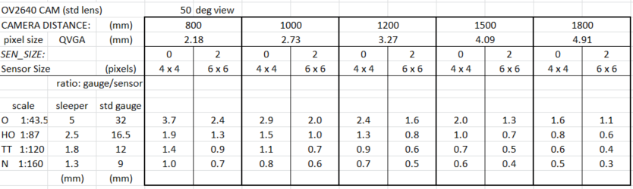

**Table 1. Comparison of sensor sizes and track features: Ratio of gauge/sensor dimension**

1. **PROCESSING4 monitor/console**

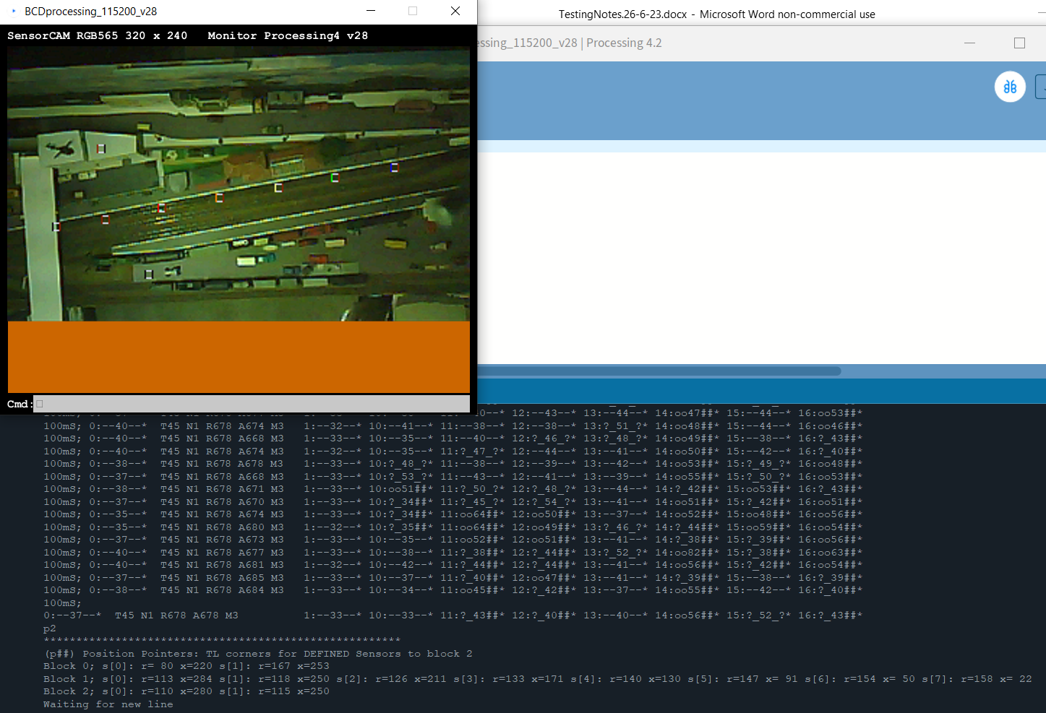

**Figure 5 Processing 4 Console and image window**  Note: Sub-optimum ‘c’ settings caused green tint.

The Processing application displays the image using sensorCAM settings, and also shows colour coded sensors.

As previously stated, the PROCESSING4 application is a crude USB monitor that enables the user to control and configure the sensorCAM with the additional benefit of being able to invoke a display of the image. All the sensorCAM commands can be used. At 115200 baud, a full RGB565 image takes 13 seconds, but it is often convenient to reduce this by prescribing a smaller image segment of limited rows and/or columns. The Processing 4 application can be downloaded from this URL: <https://processing.org>

The SensorCAM.pde code assumes the USB port for the sensorCAM is the lowest (*comNo=0;*) on the list displayed on startup. Should this not be the case, for example if another USB is being used to simultaneously run an IDE to a Command Station, then the first code line of the *.pde* will need to be increased from 0 to, for example, *int comNo=1;*

The supplied sensorCAM.pde may not load images properly (lots of timeouts) unless your computer is particularly powerful. If it is hampered by insufficient speed then the .pid program can be converted to a .exe (executable app) using the **File – Export Application** Processing 4 function. Processing 4.2 and 4.3 have been tested successfully. 

The sensorCAM Processing 4 monitor accepts commands W, X, Y & Z which allow one to nominate a “strip” or subsection to image. e.g. Z80  X240  Y  will provide the last quarter image (columns 240-319) of the 240x320 pixels in 4 seconds. This method enables, for example, comparison of quarter images under different lighting conditions by using different X values. . Similarly W60 Y120  will produce a quarter image from row 120. Each part image is pasted over previous images. Each new image appears more quickly if only a subsection is specified this way. The ***next*** image can be flipped Vertically (y) and Horizontally(x) by using V &/or H *before* capture. The Figure 5 image used V  H  Y60. The values for V, H, W, X & Z are remembered for subsequent ‘Yrrr’ commands so need not be repeated.

The image will have enabled (bs) sensors boxed & identified by a (resistor) colour code. Left bar is bank# & right bar is sensor#. Combined, they give the bsNo. If two sensors have the same coordinates, the colour code will be for the highest bsNo. Only sensors below maxSensors will be boxed. Note the ‘H’ command will REVERSE the coding from b/s to s/b. (The resistor code std. is 0:black 1:brown 2:red 3:orange 4:yellow 5:green 6:blue 7:violet 8:grey 9:white)

**PROCESSING4 command summary:**

**W###** will limit the image to ### rows wide/high (1-240) - default 240

**X###** will start the image from column ### (0-319) – default 0 – uses the sensorCAM ‘x’ command.

**Y###** will **initiate** an image download starting at row ### (0-239) – default 0 – uses the sensorCAM’s ‘y’ cmd.

**Z###** will limit the image to ### columns (1-320) – default 320 – uses the sensorCAM ‘z’ command.

**H** will flip/mirror subsequent images horizontally(x). (Note: reverses bsNo sensor colour code to s-b! )

**V** will flip/mirror subsequent images vertically(y). ( V + H effectively rotates image 180 degrees)

**R** will cause a firmware reset of the sensorCAM via the DTR line of the FTDI interface. CAM will enter a wait mode for confirmation. Reset can be aborted with command ‘**aw**’ (AbortWait). **Ctrl-R** Resets CAM instantly.

NOTE:

1. The above commands ARE CASE SENSITIVE. They are recognized by Processing 4 as non-sensorCAM commands and processed in the monitor. Commands X, Y, & Z in turn automatically issue related sensorCAM commands x, y, and z respectively, with appropriate parameters. The ‘y’ command is used repeatedly, once for each new image line (row). The ‘y’ command suspends sesnorCAM looping, holding a single “frozen” frame until a terminating command is received. To resume normal operation at the end of command ‘Y’, the double-y command ‘yy’ is automatically sent. However, if the user enters a ‘y’ by error (rather than upper case ‘Y’), the monitor will show a binary string of data (no image) and a manually entered ‘yy’ is needed to recover. Typing lower case x or z may also negate any previous X or Z settings.
2. If you use H to mirror, the colour coding for boxed sensor number (bs) has to be read right to left!
3. **Wiring Requirements**

For initial testing, the basic ESP32-CAM and ESP32-CAM-MB (CH340 based USB Mother Board) may be sufficient, however a number of issues arose making a prototype mother board desirable. The CAM has issues with “brownout” shutdowns apparently from insufficient power supplies under maximum load. This was resolved by providing a linear on-board supply of 5.2V. The prototype achieved this with a LM340T6 3-pin regulator, followed by a diode. An adjustable regulator (LM317?) may be a better choice. Linear regulators avoid introducing extra noise to the system images.

**Figure 6** 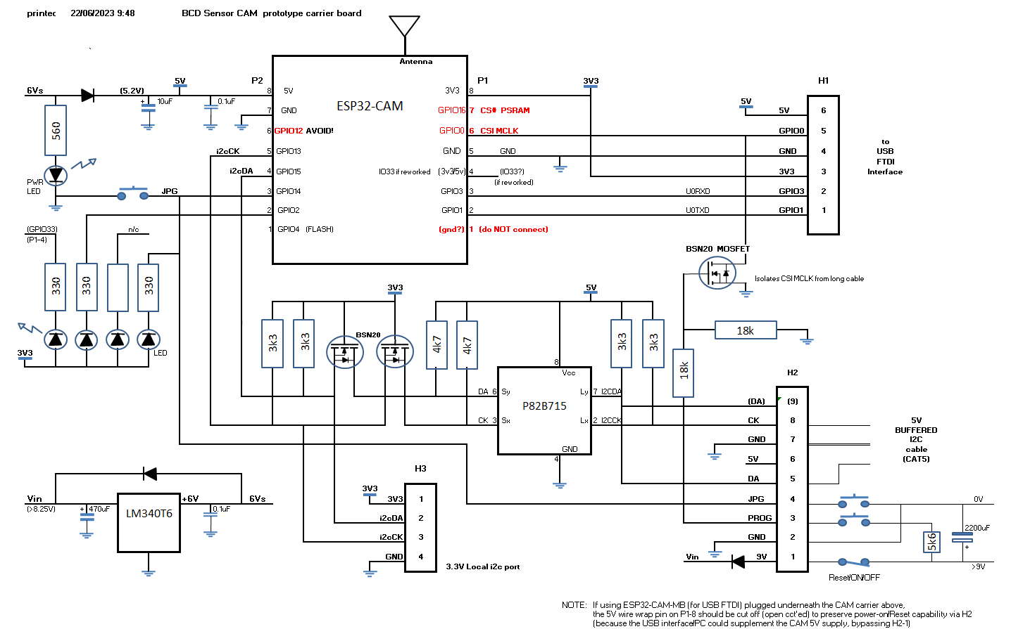

In addition, as the ESP32 outputs are 3.3V logic, to connect to a potentially long i2c bus a P82B715 buffer was added with level shifting MOSFET’s as shown, with pullups to provide a 5V i2c bus. A PCA9515A i2c module may suffice for level shifting from 3.3V to a 5V i2c bus up to 3m in length.

The system can be powered over a cat5 cable which also acts as a remote power-on reset as the on-board reset is/will be inaccessible. Note that the ESP32 +5V pin must NOT plug into the USB MB for the power-on RESET to work with a USB connected, as the USB can otherwise hold power to the CAM. If an ESP32-CAM-MB is not used, a remote programming option was placed on GPIO0 isolated with a MOSFET as GPIO0 is also used as a Clock for the CAM. GPIO14 can be used for a remote manual flag for a WiFi mode power-up if needed.

With the 6V regulator, a FLOATING unregulated 9V DC supply is adequate to supply up to 0.4A over the cat5 cable. 1.2W can be handled without a heat sink. As the supply is remote, an electrolytic filter capacitor was added with two pushbuttons and a power (reset) switch part way along the cable in a reachable location. An **ungrounded** 9V DC source ( “plug-pack”) is needed to avoid any ground current in the two i2c data ground wires paired with SCK and SDA (both ground wires connected to pin 7 of H2. Header H2 Pin 6 was NOT used.

An aerial was fitted only because of poor WiFi reception at the CAM location. Good WiFi locations need no aerial. NOTE that an Aerial attachment requires a solder link adjustment on the CAM. (refer you-tube CAM tutorials).

A GPIO2 LED is used for a bank 1 occupancy indicator and GPIO14 LED is used as a programmable bank occupancy indicator (set by ‘n’ command). With MB, H2-pin3 connected components for PROG are essentially redundant.

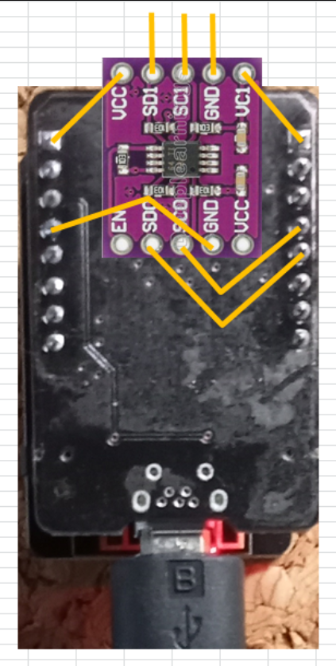 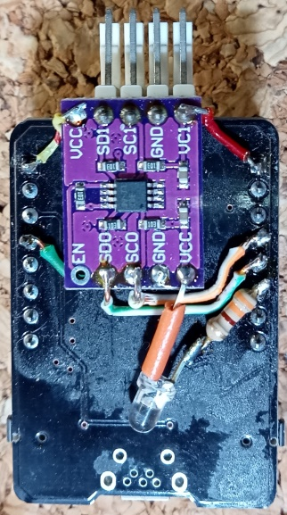 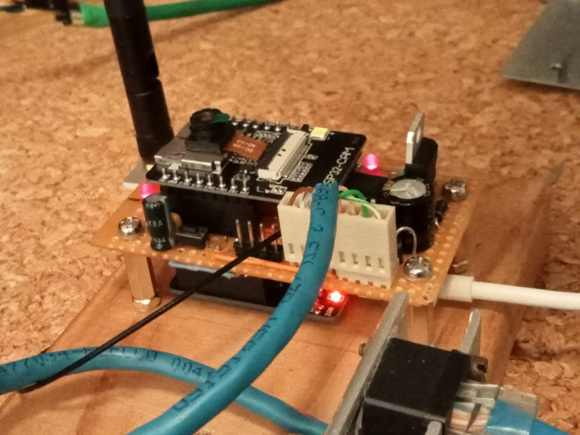

**Figure 7. PCA9515A 3.3V to 5V i2c interface improvisation compared to a full feature solution**

1. **Communication and Host Operation**

**8.1** **Intro:** The operation of the railway depends on a Control Station that polls the sensorCAM for sensor states. This might be a dedicated Arduino Mega 2560 for example. It might be a Command Station running DCC-EX & EXRAIL software, or your own personal device & code. If the sensorCAM is powered up with default settings (from EPROM), or adjusted by the user at the start, the program need only talk to sensorCAM over an i2c bus using the commands a, b, i, l & o for example, or it may be more sophisticated, providing a channel from a Control Station console to the sensorCAM to enable all configuration commands via the i2c bus.

The i2c bus is running at 100kHz on the prototype software. It has not been tested at any higher speed yet. It is running fine over a 20m long i2c bus to the master microcontroller (uC or Mega).

**8.2 DCC-EX CS:** Setting up a DCC-EX Command Station, should you have one, requires configuration details placed in files **config.h, myHal.cpp, mySetup.h** along with a new driver **EXSensorCAM.h** and command filter **myFilter.h**. These must go in the directory containing file CommandStation-EX.ino. The EXSensorCAM.h is an extended version of the EXIOExpander.h code. Consequently EXSensorCAM.h can serve as a replacement for EXIOEpander.h to avoid duplication, if memory savings are required. Refer to APPENDIX H for installation details. *EXSensorCAM.h* code mirrors the i, l, o, t & m commands, while the EXIODPUP command may serve as the enable function(a). *EXIOExpander.h* codes don’t have the “control & setup” sensorCAM functions otherwise available from a USB console so additional functionality was added using the DCC-EX user defined code <U> through the *filter.h* code.

**8.3 Proprietary Master:** If writing raw code for a Control Station, you will need details on the protocol used by sensorCAM on the i2c bus, and code to interpret the bus bytes and reconstitute text for the console. Two such prototype examples exists. V155 of sensorCAM incorporates a subset of the DCC-EX IOexpander codes so that EXRAIL can use sensorCAM without further modification.

**8.4 Gross Lighting changes** will have two effects, namely cause trips of most sensors and stop automatic reference refreshes, it may be wise to include monitoring for this eventuality by detecting and setting an “alarm” state. The reference sensor (S00) is automatically re-referenced every 6.4 seconds so will indicate a fault-trip for a maximum of 6.4 seconds. All other sensors will continue to indicate a trip until the user resets the references with an r00 (having checked all unoccupied). Setting up a second “reference” sensor (say S01) that would NOT get reset automatically and would stay tripped as a more enduring fault indicator could be helpful. You could reserve entire bank 0 for this purpose or use the’n0’ command to set the programmable pLED to light up if there is any enduring trip on bank 0. By default BLK0LED was set to GPIO2 LED, while BLK1LED to BLK3LED are set to GPIO33 LED. pLED is set to GPIO14.

**9. Methodology of operation**

**9.1 Overview:** The sensorCAM monitors up to 80 small square images (virtual sensors) each consisting of 16 pixels (4x4) the coordinates of which relate to the row/column of the top left pixel. The top left pixel of the QVGA (240x320) image is an r,c coordinate of 0,0. Sensors with coordinate 0,0 are considered “undefined”. Sensors are electrically ‘noisy’, so much effort was applied to avoid noise trips.

After bootup, every virtual sensor is imaged and a *Sensor_ref*[] recorded. This is a ONE frame grab as a first guess. All sensors should preferably be **UNoccupied** **at boot up**. If not, the user will have to manually take reference grabs at an appropriate time using the ‘r%%’ commands. The ‘r%%’ also triggers an IMMEDIATE start of a 3.2sec average Ref for S%%. ‘r00’ triggers a 1 frame reference refresh for ALL sensors but also starts the auto reference process, as does r%%. The latest version, at bootup, commences regular averaged reference updates assuming all unoccupied. If an occupied state occurs during the averaging, the averaged ref. is rejected.

Every 100mSec the sensor pixels are decoded from the RGB565 QVGA image (2 byte) into RGB666 3 byte format and compared with the reference sensor image (in *Sensor_ref*[]) for changes. To allow for drifting light intensity, *Sensor_ref*[] needs to be periodically updated. The automatic updates occur for each enabled sensor (0/1 through 9/7 sequentially, each using a 32 sample average (in ~3.5seconds) and replacing the old *Sensor_ref*[] **provided** there were no “trips” of the sensor during the sample period (3.5sec.). Hence updates occur only when sensor is UNoccupied, and only once every N*3.5sec. (N being the number of enabled sensors). The brightness sensor (S00) is updated independently **every** 6.4 seconds with a 64 sample average. Each update is flagged to the monitor as it occurs (as “Ref 0%%”). It is inadvisable to leave a sensor occupied for long periods if best reliability is desired. If a sensor is occupied for long periods of drifting illumination, the ref can become out-of-date to an extent that the sensor can remain PERMANENTLY “occupied”. Manual re-referencing (r%%) would become necessary.

To detect a “trip” of a sensor, an algorithm evaluates a “difference” score between *Sensor666*[] and *Sensor_ref*[]. The (*bpd*) score is a brightness plus colour-diff sum. This (*bpd*) score is compared with the *threshold* (‘t%%’) value. If it exceeds the threshold, a flag is set and if after “*min2trip*” frames it remains set, then the Sensor “trips”. It will then fall back (untrip) if *min2trip* frames go below *threshold*. *min2trip* is set to 2 by default as 3 will give a +100mS delayed response. The monitor data stream (scroll) includes the bsNo %%, potential for trip “?-“, the “*bpd*” score, or actual trip “oo” and “##”. If a twin (see below) inhibits trip it indicates this with “?T”. Minimum *bpd* is 32 (identical). e.g. 12:--38--* 13:?-46-?* 14:oo50##* 15:?-53?T* 16:--35--*

A “second opinion” may be used to maintain a quick “trip” with greater reliability. This involves setting up a second “twin” sensor adjacent to the primary sensor. The primary sensor will only trip if the secondary sensor agrees. (e.g. example for bsNo. 1/5 above). The ‘i%%,$$’ command nominates a twin sensor (S$$) for sensor S%%. The (non-00) twin should have a lower bsNo than the primary to avoid extra delay, as they are evaluated in ascending bsNo order.

As the sensor image suffers from excessive noise at low light levels, another averaging process has been included. For bsNo.s below 3/0 (parameter TWOIMAGE_MAXBS) , two consecutive images are averaged to remove noise spikes. The effect can be observed if one watches two sensors with the same coordinates but above and below 3/0, and with a suitably low temporary threshold.. This cutoff point (3/0) can be extended to higher banks as well by editing the #define statement in *sensorCAM.ino* *#define TWOIMAGE_MAXBS 030*

The sensor size can be padded out (enlarged) with dummy pixels using *#define SEN_SIZE 2*  in file configCAM.h

**9.2 Algorithm description:** The algorithm for *bpd* is weighted heavily towards colour changes rather than brightness. This reduces the sensitivity to mains frequency lighting flicker, and drifting light intensity (e.g. daylight). The algorithm for comparing colours is somewhat complex and may well be improved in later versions. The focus of detection is changing colours as opposed to changing brightness. To this end each sensor (4x4) is divided into four quadrants of rgb colour. The colour brightness factor is removed by an algorithm computing the colour ratios r/g g/b b/r in each quadrant. These ratios are compared to that of the reference image for changes. The process in more detail is as follows:

Each sensor is split into 4 quadrants(quad), each quad has 4 pixels of 3 colours (48 x 6-bit bytes in total)

The sum of all 12 bytes(4*3) in a quad is found as a quad brightness (4off) and the sum(4) of each colour (rgb) for each quad is found giving a total of 12 colour sums (3 colours * 4 quads) plus 4 brightness values

Within each quad, 3 colour ratios are calculated for Red/green green/blue blue/red (largest(*32) divided by smallest (any 0 changed to 1) to give 12 colour ratios, each >=32 (32 if identical) ( placed in array *Cratio[12]* )

Compare the values in *Cratio[12]* with the reference array (precomputed from *Sensor_ref[]* ) and find the maximum “Xratio” between the two sets of 12 “Cratios” using the same formula (giving Xratios of 32 to 2016)

Set *maxDiff* to the largest ratio for a sensor from the 12 “xratios”

A brightness score is similarly calculated between the full ref. brightness and that for the current sensor using formula *16*bright/Sen_Brightness_Ref[bsn] -16*. It is scaled to give a value from 0 upwards. With SF=2, a score of 2 represents about 7% brighter so is relatively insensitive. Code uses *int* so, <=6% difference gives a 0 score.

The “diff” score (*bpd*) comprises of ( *bright * brightSF* + *maxDiff* ) (>=32) and is weighted towards colour difference + small brightness component (of 2 for 7% change)

The diff (*bpd*) is compared to threshold for a decision on trip state. If greater than threshold, several additional checks are made including requiring 2 consecutive frames to exceed threshold, averaging pixels over two frames, and possibly confirmation from a twin sensor. These contribute to an additional response time delay (+100mSec). Furthermore the reference image is normally based on a 32 frame average pixel to eliminate any “noise” in the sensor reference itself.

**9.3 Program Summary:** Once the sensorCAM parameters and environmental conditions are set, the sensorCAM will run continuously, looping once per 100mSec. Each loop takes the following steps:

1. // ****IF IN MYWEBSERVER MODE, JUST MONITOR SERIAL PORTS FOR RESET (R or F)
2. // ****CALCULATE AND PRINT LOOP TIME - & IF CALLED FOR, UPDATE NEW CAMERA SETTINGS
3. // ****TAKE A FULL FRAME INTO fb IN RGB565 FORMAT
4. // ****DECODE RGB565 FRAME INTO COMPACT SENSOR FRAME OF RGB666 FORMAT
5. // ****SEE IF IMAGE DUMP (TO PROCESSING4) CALLED FOR & DUMP AS REQUESTED BEFORE NEW FRAME INITIATED
6. // ****BEFORE DISCARDING RGB565 fb FRAME, CHECK IF NEEDED TO PROCESS A sCAN or cALIBRATE COMMAND REQUEST
7. // ****DO A STEP TOWARDS AVERAGING Sensor[bsNo] IF COUNTER SET.
8. // ****CALCULATE ROLLING AVERAGE FOR Sensor[00] AND AVERAGE NOISE (& PEAK NOISE?)
9. // ****DELAY TO REDUCE FRAMES PER SECOND FROM one/80mS to one/100mSec FOR PSRAM 25% IDLE (DE-STRESS) TIME.
10. // ****FOR FLUORESCENT LIGHTING TRY TO SYNCHRONISE release/start image WITH 50Hz MAINS USING INTERNAL CLOCK
11. // ****IF CALLED FOR BY c####, OR STARTUP(), DO A FULL REFERENCE UPDATE FOR ALL ENABLED SENSORS
12. // ****NOW WANT TO CLEAR CAMERA PIPELINE & START NEW IMAGE CAPTURE FOR NEXT LOOP
13. // ****DO COMPARE OF ALL SENSORS WITH THEIR REF'S, DECIDE IF OCCUPIED & IF SO SET STATUS.
14. // ****USE 2 image average for compare only if bsNo < *TWOIMAGE_MAXBS* as a method for improving algorithm.
15. // ****CHECK DFLAG AND OUTPUT REQUESTED INFO FOR ‘d’ cmd
16. // ****FLASH A LED ON EACH LOOP. Use FLASHLED pin
17. // ****CHECK FOR USB COMMAND INPUT - PROCESS ANY COMMAND

**APPENDIX A**

**ESP32 sensorCAM Command Summary 21/2/24**

Can have 10 banks (0-9) of sensors. Each bank can have up to 8 enabled sensors (0-7). Bank/sensor No. up to ‘97’.

Array *Sensor*[n] holds coordinates (rx) of sensor n. Offsets are long int. Array uses 88+320 bytes (10*8*4) EEPROM.

Sensors are grouped into banks (b) of individuals (i). e.g. bsNo 6/7 identifies bank 6 individual 7. (n=8*6+7=55=067)

Sensors are **undefined** if coordinates (rx) are set to 00. They are **disabled** if SensorActive[n] is set to false.

If a sensor detects differences, then any output LED assigned to the associated Bank of sensors should turn ON.

On reset (power-up), reference grabs are taken for all defined (in EEPROM) sensors, and then enables them.

To define a sensor, place a bright LED on the desired spot and dim lighting, then “scan”. Save in EEPROM. (‘e’)

Sensor CAM uses RGB565 image format which is incompatible with JPG, so Reboots between either Sensor OR WiFi.

**Commands below are received over the USB or i2c interfaces.**

**s%%** * **Scan** for new location for sensor %% (00-97). If found, records location in *Sensor*[%%]. Further setup needed. Scan looks for a bright LED on a dimmer background. The LED should be placed on the desired sensor position. If satisfied with the scan, the user should REMOVE the LED, set lighting, & do an r%% to both set the sensor enabled & record a new reference image. (also computes colour ratios & brightness). Sensor location must be unoccupied!

**w * Wait** for new command line (\n) before resuming loop() (handy to stop display data scrolling – see t1 toggle)

**a%%** **enAble** *Sensor*[%%] & refresh *Sensor_ref*[%%], cRatios etc. from image (48 bytes) in latest frame. **(Note 19.)**

**b#** **Bank** # sensors. Show which sensors OCCUPIED (in bits 7-0). (1=occ.) (b#$ sets *brightSF*) Req. #+1 *data bytes*

**c$$$$ \*** re**Calibrate** camera CCD occasionally and grab new references for all enabled sensors (Beware of doing this while any sensors are occupied! NB.Obstructed sensors will later need an **r%%** ! Check all bank LEDS are off AND check all sensors are unoccupied before recalibrate. Can set AWB AEC AGC CB through $$$$ e.g. c0110 Also able to change default setting for Brightness, Contrast & Saturation with extra digits e.g. c$$$$012

**d%%[#]** \***Difference score in colour & brightness** between Ref & actual image. Show # grabs. Request 4 *data bytes*

**e EPROM** save of any new Sensor offset positions, new twins & 5 default parameter settings**.**

**f%% * Frame** buffer sample display. Print latest bytes in *Sensor_ref*[##] & *Sensor*[%%] positions. Request 4*x28 bytes*

**g * Get Camera Status.** Displays most current settings available in webcam window. (both sensor & video mode)

**h$ * Help**(debug) output. h- to set all OFF, h0 turn ON detailed USB output. h1:more; h2:timing; h3:i2c; h4:Noise

**i%%**[,$$] **Info.** on sensor S%%. State (0 or 1,1=occupied); position r,x ; & twin. [may assign S$$ as twin] 8 *data bytes*

**j$# * adJust camera setting $** to value #and display most settings (as for ‘g’) ‘j’ alone lists the options for $#

**k%%,rrr,xxx * Set coordinates** of *Sensor* S%% to row: rrr & column: xxx. Follow with **r%%**. Verify values with **p$**

**l%%** (Lima) force sensor %% to on (1= occupied (LED **lit**) & also set *SensorActive*[%%] false to disable sensing.

**m$[,##] *Minimum** $ number(2) of sequential frames >Threshold to trigger/trip sensor . Show parameters (Note 13)

**n# bank Number #** assignment to the programmable *nLED* to show its occupancy status.

**o%%** (Oscar)Force sensor %% **off** (0=UN-occupied (LED **off**) & also set *SensorActive*[##] false to disable updating.

**p$ * Position Pointer** table info for banks 0 to $ giving DEFINED sensor r/x positions. p%% shorter. *<32 data bytes*

**q$ \*** **Query bank** $, to show which sensors ENABLED (in bits 7-0). 1=enabled. q9 gives ALL Request $+2 *data bytes*

**r%%** **Refresh Average** Sensor_**Ref**[##] (If defined), enable & calc. cRatios etc. r%%* refreshes block S%0 to S%%

**r00** **Refresh Average Refs** etc. **for ALL** defined sensors. Ignores enable[]. *Sensor*[00] reserved for brightness ref.

**t##[,%%] Threshold** level being used (t## sets 31-99), %% sets *pvtThreshold[],* t1 toggles scroll Request 1+ *data bytes*

**u%%**  **Un-define/remove** sensor %% (*Sensor[%%]=*0 & set DISABLED) u99 for ALL. Cmd **‘e’** will erase from EPROM.

**v Video mode.** Causes reboot as a **webserver**.“**v2**” will connect to 2nd (alt.) router ssid. (“**ver**” gives version)

**R** & **F * Reset commands – will Reset CAM and initiate the Sensor mode. Both will Finish the WebServer (v) mode.**

**x### * selects** first pixel column (0-319) & **z###** * selects image width (### columns (1-320)) for imaging.

**y### selects first row for image and initiates a binary data dump for that row (header + #*2 bytes) using rgb565. This command starts a process that must, after a series of ‘y’ commands, end with a terminator of ‘yy’.**

**& * statistics histogram** on trips and potential trips, then reset counters and start another sample process. The table gives number of single highs, double highs etc. and totals for No. of frames/run time

* These commands typically for diagnostic/setup use only. They wait for a line feed or command to resume.

**Note: The value of “n” (sensors 0-79dec.) is printed in several formats. For data entry, bsNo format (%% e.g. 47) is bank/item, so n=8*4+7=39dec. It may be printed as (char) 47, 4/7, (octal) 047, or (hex) 0x27 depending on context. Debug output most likely uses OCT or HEX. Note: OCT 0107 = 8/7, 0117 = 9/7, hex 0x2F = 5/7.**

**Startup Notes:**

1. Normal power up reset will initiate Sensor mode, as will the ‘R’ command, and uses EPROM data settings.
2. Sensor mode startup flashes white LED at 10Hz after ~10 seconds, and exhibits a “flicker” at ~20 seconds.
3. Requested (v) WebServer mode reset will flash LED at ~3seconds and again (brighter) at ~8 seconds.
4. After the 8 second flash the Webserver will be operational at web address 192.168.0.xx (xx from display)
5. If the OV2640 camera or WiFi fails to initialize, the CAM resets and may restart/revert into Sensor mode!
6. BUG!! If USB FTDI/MB is removed or not connected to PC, then WebServer seems to fail/reboot.

**I2C command Notes: (**EX-CS may exhibit small variations & reduced cmd functionality depending on driver)

1. The same commands are valid from an I2C Master Arduino, but there are some variations.
2. The commands with asterisks normally pause CAM execution so the operator can read USB output on a monitor screen. The same commands from I2C DO NOT wait for a new line, with the exception of ‘w’.
3. Commands **b, d, i, m, p, q** & **t** can return data to the I2C master Arduino (Mega). This data is delivered if the master calls a *Wire.requestFrom*(addr,#); following the command, from the slave CAM address 17 (0x11).
4. The I2C data returned (after header byte) is in binary bytes and in a format depending on the last command.
5. Header byte[0] is the ASCII command character (b, d. i, m, p, q, or t) or an error code (0xFE) if no valid data.
6. If the error code is generated, it is followed by the last received (inappropriate) command string.
7. **b$** cmd returns $+1 sensor status bytes for bank $, $-1 etc. down to bank 0. ‘b’ defaults to ‘b9’ (all).
8. **d%%** cmd returns 4 data bytes with binary values for bsn, maxDiff+bright, maxDiff & bright in that order.
9. **i%%** cmd returns 2 data bytes. byte[1] = bsn and byte[2]=0 if unoccupied or 1 (true) if occupied.
10. **p$** cmd returns Byte[0]header + count + 3 data bytes per enabled (bank $) sensor + parity (max 27 bytes).
11. **q$** cmd returns $+1 bank sensor enabled status bytes for bank $, $-1 etc. down to bank 0. ‘q’ defaults to ‘q1’
12. **t** command initially returns the old threshold value ( i.e. BEFORE it is reset in the case of **t##**). Also returns sensor scores (*bpd*) in 2-byte pairs with MSB set so: *bsn*(+0x80 if undecided) & *bpd*(+0x80 if OCCUPIED).

Byte[0]header;[1]threshold;[2]S00bpd;[3]bsn;[4]bpd;[5]bsn;[6]bpd etc. Ends with bsn=80 (max 15 enabled)

1. **m$,##** sets *maxSensors* to ## (USB or i2c) (as can **hs$** ( $ x4 = ## < 81 )). **m0,1##** sets minSensors. Extra ‘m’ data is fed to i2c bus for additional remote (e.g. EX-CS) console feedback on other parameters as well.
2. The **‘ “ ‘** character is just a null cmd. Used before **R, d** & **t** to prevent *BCD* Mega itself pre-interpreting them.
3. NOTE WELL: The ESP32-CAM uses old ESP32 which has I2C limitations. It has a “pipeline” for returning data which results in a delay in response. i.e. the first request after a command will return OLD data. A SECOND request should return the desired data described above. A third or fourth request may return updated data.
4. Some commands take time to complete, as command processing can only happen once per 100mSeconds (i.e. the frame rate of the CAM). The I2C master should allow for latency in response where necessary.
5. Data requested over i2c may have a parity byte appended, e.g. ‘b2’ command will get back header + 4 bytes.
6. NOTE Automatic updating of ref image of unoccupied sensors starts AFTER the first r%% command executed.
7. **a%%,rrr,xxx** performs extended ‘create sensor’ equivalent to k%%,rrr,xxx + a%% + r%% for new sensor %%
8. **Connection to DCC-EX Command Station under development. See APPENDIX G for revised command set**

**APPENDIX B**

**Check List for Optimising Sensor Response**

In the situation where sensors may be tripping undesirably, there is a range of adjustments that can be made to find a satisfactory operating point. Some have disadvantages that need to be considered and compromises may be necessary.

1. First step is to refresh the sensor reference image. Try Cmd: r00 or r%% for a single sensor. This may be necessary after any disturbance to the environment such as lighting.
2. Check the “Diff” scores on the scrolling display. After a refresh they should be in the range 32-39 for normal operation. If occasional trips occur, one remedy is to increase the *threshold* with Cmd: t48 say. Increasing the *threshold* reduces the sensitivity to low contrast objects (e.g. black over brown) If Diff scores are consistently 32-35, reduce threshold for greater sensitivity.
3. Is the lighting adequate? Steady muted daylight is ideal. Beware of rotating fans and other moving shadows (clouds?) (Note: may need to consider extreme case of mains induced ripple from 50/60Hz LED/fluoro lighting – to be discussed later) Brighter lighting means reduced “noise”.
4. Sensitivity to electrical “noise” can be reduced by increasing the “*min2trip*” parameter to 3 consecutive frames using Cmd: m3 (default is 2). However this increases response time by 100mS.
5. You can create a “Twin” sensor for a “second opinion” by placing a second sensor S$$ on the track adjacent to the primary sensor S%% (3-4 pixels away) by using the Cmd: a$$,123,234 calculating the position from that of the primay sensor (obtained from Cmd: i%%) To avoid increasing response time, use a twin bsNo LOWER than the primary sensor (preferably in a “reserved” bank, perhaps a matching bsNo in bank 0) This twin S$$ can be assigned to the primary sensor S%% with the Cmd: i%%,$$ The primary sensor will not trip unless the twin agrees. This suppresses pixel noise spikes.
6. Check that there isn’t anything elsewhere in the field of view that is moving and could trigger the auto exposure in the camera. e.g. spectators near the edge of the field of view. (It is possible to change camera ov2640 module settings with ‘j’ and ‘c’ commands, but this can be a frustrating experience and needs practice as some settings interact and can be order dependent)
7. Make sure you do a refresh/record reference (r) after any changes or the benefit will be obscured.
8. Is the camera steady? No vibration or movement since the last reference images (r)?
9. There is a 2-frame (experimental) averaging applied to low bank sensors (currently 0-2) This can be extended to cover all banks, if desired by increasing CAM parameter TWOIMAGE_MAXBS above 3/0
10. There has been poorer behavior observed with sensors placed near the edge of the frame. They seem to experience more electrical noise than mid-frame sensors and may need extra attention
11. A statistics function can be obtained to see how bad spurious tripping is. The ‘&’ cmd gives a table of stats accumulated since the **previous** ‘&’ command. May be useful. HINT: You can compare two or more sensors with different settings on the **same** spot. Accumulate data **with no** genuine trips.
12. Consider whether a pixel may be faulty or unduly noisy. Try another nearby sensor position.
13. If necessary, enhance the brightness of the vSensor location with light colour or a small reflector.
14. It is possible to set private thresholds on individual sensors if other solutions inadequate. (t##,%%)
15. Consider adjusting brightSF ($) if colour contrast is generally poor (b#$) default 3, try 4-5.

**APPENDIX C**

**I2C sensorCAM commands & PROTOCOL.**

With version 3.00 of IO_EXSensorCAM.h CS driver, commands and parameters are sent to the CAM as a short string of binary bytes to be interpreted by sensorCAM. Return data (if it is applicable) is also in compact byte format as below.

The sensorCAM sends packets of data to the i2c bus master upon request. The data sent is dependent on the **last** command received as that command prepares a packet in anticipation of a bus Request. Only nine commands can affect the return packet format. They will contain the relevant ASCII command character in the first (header) byte, followed by data. These are listed below.

1. Bank cmd ‘b$’: The bank command will set the Request packet to the following $+2 bytes

0x62 (‘b’) SensorBankStat[$] SensorBankStat[$-1] …….. SensorBankStat[0] i2cparity

1. Difference score ‘d%%#’ (Diff+bright): The Diff command will set the Request packet to the following 5 bytes

0x64 (‘d’) 0## *dMaxDiff+dBright* *dMaxDiff dBright*

1. Frame data ‘f%%’: Creates four packets containing 4 rows of 4 pixel values in RGB666 format of Ref and Actual pixels

Total 16x2 pixels. Each pixel has three 6bit colour bytes for a total of (3+3x4x2) 27 bytes per packet

0x66 (‘f’) 0%% 0x00 (row) RefPix0Red RefPix0Green RefPix0Blue RefPix1Red .... ActPix3Green ActPix3Blue

0x66 (‘f’) 0%% 0x01 (row) RefPix4Red RefPix4Green RefPix4Blue RefPix5Red .... ActPix7Green ActPix7Blue

0x66 (‘f’) 0%% 0x02 (row) RefPix8Red RefPix8Green RefPix8Blue RefPix9Red .... ActPixBGreen ActPixBBlue

0x66 (‘f’) 0%% 0x03 (row) RefPixCRed RefPixCGreen RefPixCBlue RefPixDRed .... ActPixFGreen ActPixFBlue

1. Individual Info. ‘i%%,%%’: The Info command will set the Request packet to the following 8 bytes. twin=00 for NO twin.

0x69 (‘i’) 0%% SensorStat SensorActive columnL columnH row twin##

1. Min/max cmd ‘m$,##’: (also n$,##) Returns 7 byte Request packet data as below for additional feedback to operator.

0x70 (‘m’) min2flip minSensors maxSensors nLED threshold TWOIMAGE_MAXBS

1. Position Pointer ‘p$’: This sends sensor coordinates for bank $. i.e. $/0, $/1, to $/7 (**only if defined**) Up to 25 bytes.

0x70 (‘p’) H+bsn for $/0 $/0 row $/0 column H+bsn for $/1 $/1 row ... H+bsn for $/7 $/7 row $/7column i2cparity

Note: if column (0-319) exceeds 255, a high bit H (=0x80) is added to the bsn byte for that triplet.

1. Query enabled ‘q$’: This will set up the Request packet of enabled status’ in the following $+2 bytes

0x71 (‘q’) ‘$’ SensorActiveBlk[$] SensorActiveBlk[$-1] …. SensorActiveBlk[0]

1. Threshold ‘t##’: Threshold command will set the Request packet to the following byte sequence of enabled sensors.

0x74 (‘t’) 0x## T+bpd data S00 2nd t+0xbsn (sensor No) 2nd T+bpd data 3rd t+0xbsn 3rd T+bpd data ……… t+Last bsn T+bpd byte 0x50 0x50 == 80 = end of data packet (an invalid bsn!). Maximum of 15 enabled sensors in 32 byte packet.

Data bytes contain “*bpd*” diff scores (0-127) for enabled sensors with MSB(T) set 1 if tripped. MSB(t) of *bsn* set if the *bpd*  > *threshold*. Byte[0] contains ASCII ‘t’ and Byte[1] will contain the last (old) setting of threshold.

1. Row image ‘y###’: This sends up to 320 x 2byte RGB565 pixels of row ### ***to USB console for image reconstruction.***

0x79 (‘y’) ‘#’ ‘#’ ‘#’ 0x78 (‘x’) ’x’ ‘x’ ’x’ 0x7A(‘z’) ’z’ ‘z’ ’z’ 0x3A(‘:’) (x & z values in ASCII bytes. ‘:’ starts 9 byte header)

0x79 (‘y’) 0x## (row) 0x78 (‘x’) 0x##(column/2) 0x7A(‘z’] 0x## (zlength/2) chksumL chksumH 0x3A(‘:’) 1st data byte 2nd data byte] …. Last data byte] (2 RGB65 bytes/pixel with no NUL characters. Even column start)

**APPENDIX D**

**I2C DCC-EX CS IO_EXIOExpander commands & PROTOCOL.**

EX-**Expander Commands/codes May invoke sensorCAM command**

(choices may depend on ID number 0-7, 8 or 9)

* **EXIOINIT** = 0xE0 - Initialise the setup procedure (init) responds with EXIOPINS & setup numbers
* EXIORDY = 0xE1 - Setup procedure complete sent if command accepted as OK
* **EXIODPUP** = 0xE2 - Send digital pin pullup configuration acknowledge EXIORDY – no other action
* **EXIOVER** = 0xE3 - Get version ver return version
* **EXIORDAN** = 0xE4 - Read an (analogue) input byte treated as an EXIORDD sending same digital packet
* **EXIOWRD** = 0xE5 - Send a digital write a enable a sensor and refresh
* **EXIORDD** = 0xE6 - Read all digital inputs (100 times/sec) i return all sensor states (& bank states)
* EXIOENAN = 0xE7 - Enable an analogue input acknowledge EXIORDY – no other action
* **EXIOINITA** = 0xE8 – Request/receive analogue pin mappings returns a dummy analogue pin map
* EXIOPINS = 0xE9 - Request/receive buffer counts (init) used to respond to EXIOINIT cmd
* **EXIOWRAN** = 0xEA - Send a bytewise write (PWM) r g t m j n k a set threshold,min2trip,maxSensors etc.
* EXIOERR = 0xEF - Error sent/received return error/not OK

Sensor numbers are to be in a range of CAMoffset+0 to CAMoffset+79. Only 80 are valid numbers (vPins).

This means digital vPin numbers do **not** readily indicate bank and sensor (b/s) format.

**Command Request response, packet bytes**

EXIOINIT(0xE0) nPins firstVpinL firstVpinH EXIOPINS(0xE9) *numDigPins numAnalogPins*

nPins is # required? Starting at firstVpin provides numbers available OR no. allocated??

EXIODPUP(0xE2) pin pullup <S id vpin pup> EXIORDY(0xE1) OR other (EXIOERR?)

Pin is the index from firstVpin, Boolean pullup check pin no. & set pin pullup state

EXIOVER(0xE3) majorVer minorVer patchVer

Request version e.g. 0.1.53

EXIORDAN(0xE4) (full set) val0L val0H val1L val1H val2L …..

Request a burst of ALL *numAnaloguePins* values? One packet limited to 16x2 bytes?

**IO_EXIOExexpander.h driver sends this command every 50mSec!**

EXIOWRD(0xE5) pin value <Z id vpin iflag > EXIORDY(0xE1) or other (EXIOERR?)

Send required pin setting set or reset output pin

EXIORDD(0xE6) Bank0 Bank1 Bank2 … Bank[*numDigitalPins*+7)/8]

Request full digital read (up to numDigitalPins) Presume the order is as above & pin 0 == LSB of Bank0

**IO_EXIOExexpander.h driver sends this command every 10mSec! between slower EXIORDANs**

EXIOENAN(0xE7) pin EXIORDY(0xE1) or other (EXIOERR?) e.g.if invalid A.pin

analogue input configuration not clear what exexpander or CAM expected to do?

EXIOINITA(0xE8) BYTE1 … BYTE*numAnaloguePins*

Need to retrieve the analogue pin map Nano Map=(12,13,14,15,16,17} 6 analog pins above D’s

For NANO, map has 6 vpin values above 12 D pins One byte per pin, total *numAnaloguePins*

EXIOWRAN(0xEA) pin valueL valueH profile durationL durationH One doc. says NO RESPONSE NEEDED!

Request setting of a servo PWM output EXIORDY(0xE1) or (EXIOERR?) IS anticipated by code.

EXIOPINS(0xE9) … is response to EXIOINIT above EXIOERR(0xEF) … is error response

**Problems with standard IO_EXIOexpander.h**

This driver does not allow for the peculiarities of ESP32 i2c communication. The returned “request” packet may be delayed by one cycle. The EXIOExpander.h driver does NOT check that the response to an i2c onRequest is for the command sent. The protocol has no provision for this check and repeat request. Consequently a driver modification has been added to the EXIOExpander.h file specifically for any (ESP32) device found to get the CAM initialized and communicating while maintaining the original functionality for normal IOExpanders. The default CAM address is 0x11.

EXIOSensorCAM.h v2.01+ abandons compatibility with EXIOExpander.h driver while still using similar protocols. It can no-longer drive EXIOExpanders (Nano’s etc).

To avoid excessive i2c traffic, the work-around for the CAM treats EXIORDD and EXIORDAN equivalently returning identically formatted packets containing 80 digital pins (10 bytes). The CAM has a total of 80 vpins (0-79). Valid digital data appears in EVERY packet request sent at the nominated rate of 25mSec intervals PROVIDED no ESP32 sensorCAM commands (<N>) are injected. Consistent Packets are therefore ALWAYS valid during free running (but delayed 1 cycle). For infrequent commands the driver will read several packets if needed to obtain valid data and will conclude with a fresh EXIORDD.

Currently neither CS or IO_EXIOExpander has any standard way to read one sensorCAM bank (8bit) status, although the bytes are read and usually stored every 10mSec! The sensorCAM driver has the added ability over EXIOExpander to respond to “A Native INput” command <D ANIN vPin> with the status value (0-255) of the block containing vPin directly from ***digitalInputStates*[].**  This enables the use of a planned sequence of sensors to be tested with a single IFGTE(), IFLT() etc. The entire bank can be tested if “empty” with IFLT(vpin,1) single ex-rail command, or if partially occupied, with IFGTE(vpin,8) say. This also expedites the use of a “curtain” of (“linear”) sensors for siding occupancy or for intruder detection (arms, heads, cats, etc.).

**APPENDIX E**

**Tabulation of Recommended DCC-EX-CS id’s for sensorCAM**

The id consists of CAM number #-bank-sensor or #bs. Each bank (0-9) contains 8 sensors (0-7)

ID is the CAM number # x 100 + bsNo skipping id’s ending in 8 or 9.

vPin is the base/first vPin number (e.g. 700) + DEC (*bsn*)number in table below

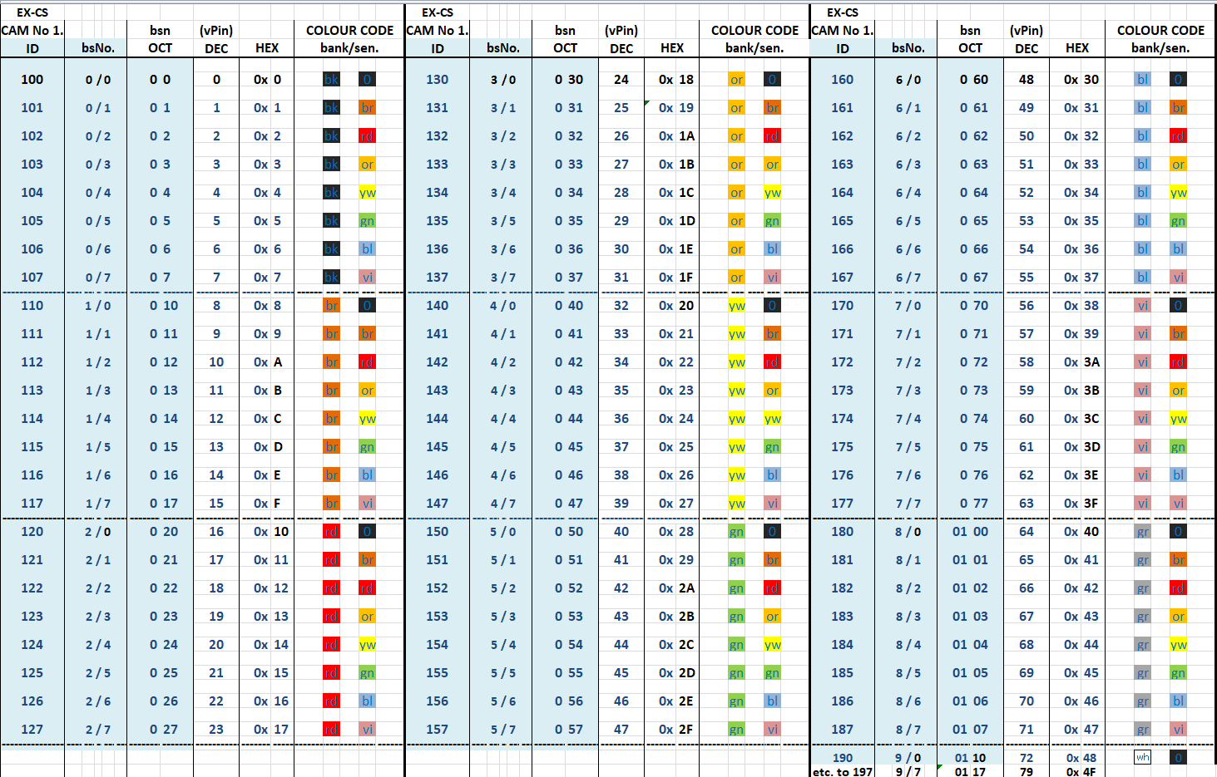

**APPENDIX F**

**Hardware Notes.** **(including PCA9515A)**

The CAM drives GPIO pins with 3.3V logic. This may well be incompatible with the master I2C signals at 5V. It is essential that appropriate voltage level shifting and buffering is used where necessary. Unbuffered I2C is limited in range but a cheap P82B715 bus extender gives up to 30m of I2C capability. The prototype Sensor CAM is mounted on a “vero” board that holds two bank trip LEDs, power LED, I2C buffer, a number of required pull-up resistors, capacitors and a voltage regulator so that it can operate and be powered over a single 5m CAT5 cable for greater convenience. A 3m USB connection need only be used for setup and diagnosis. The prototype vero plugs into the socket of ESP32-CAM MB USB adaptor (with 5V pin cut off) but can also use other FTDI interfaces.

The CAM prototype can be Resetremotely by software or by cycling the power supply. It can be placed in program mode by a logic signal (GPIO0) over the CAT5 cable if needed, and similarly placed in WebServer mode (GPIO14) or Sensor mode remotely independent of I2C master. The GPIO0 & 14 pins may be isolated from CAT5 cable with MOSFETS. The CAM MUST be rigidly mounted as it’s response to any image vibration can trip sensors. It is best not moved after sensor location programming as precise realignment could be tedious. It is, however, advisable to make guides or jig arrangement to at least be able to remove (for maintenance) and return with minimal misalignment to cover the same field of view. The LED method of placing/positioning sensors may be necessary if a long USB cable is impractical. A 5m buffered USB cable might be advantageous. Even so, programming or imaging over a long USB cable may never be satisfactory.

For a simpler, but limited, interface to an i2c bus the use of a PCA9515A based module will act as a level changer (3.3V to 5V) and can connect to a SHORT i2c bus (max 3m). Use 2mm foam adhesive tape to mount 9515 on MB.

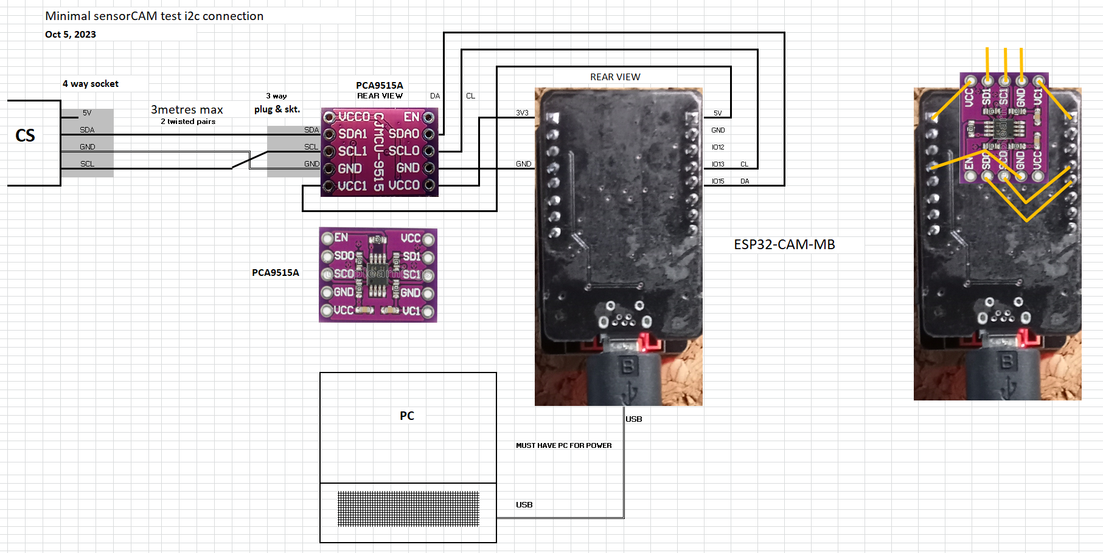

The programmable LED and 330ohm resistor could be attached from 3.3V VCC to GPIO14 if desired.

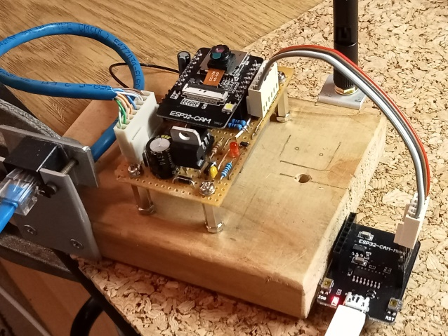 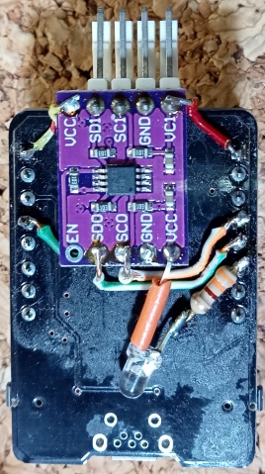 

**APPENDIX G**

**Filtered DCC EX-CS commands**

The file *myFilter.cpp* has been added to the CS specifically tailored to provide a mechanism for the CS to send commands more easily than by using the diagnostic command style <D ANOUT vpin parm1 parm2>. Native CAM command format is <N c [parm1] [parm2]> where command character ‘c’ can be any of those listed below. Generally, to effect changes in sensorCAM, **the CAM must be in the run mode (flashing).**

The base vpin address defaults to 700 but one can use the #define SENSORCAM_VPIN0 for another value (in config.h). With 2 to 4 CAM’s, use <N C vpin0> when a switch is needed. The CAM # may also be placed before the sensor bsNo if listed in config.h. e.g. <Ni 2%%> <Nr 2%%> also <Nm 200> <Nx 200> <Nt 243>

**User command example equivalent sensorCAM command and action** (only some return data to CS)

<N C vpin> <N C 600> (Set base vpin for following CAM commands (used if have multiple CAMs).)

<N o bsNo> <N o 12> o12 (oscar) Zero output state of sensor *bsNo* to 0 & disable.

<N l bsNo> <N l 12> l12 (lima) Set output state of sensor *bsNo* to 1 & disable.

<N a bsNo> <N a 12> a12 enAble sensor *bsNo*.

<N b bank#> <N b 1> b1 Bank sensor states (all 8). (used by IFGTE() ATLT() e.g. to locate loco)

<N e> <N e> e EPROM write any changed settings to sensorCAM EPROM.

<N f bsNo> <N f 12> f12 Frame image pixel data for *Sensor_ref[]* and *sensor666[]* (RGB bytes)

<N F> <N F> F Forced Reboot restoring sensorCAM sensor mode & EPROM defaults.

<N g> <N g> g lists ov2640 camera module settings (on **sensorCAM monitor**).

<N j $ #> <N j B 2> jB2 set ov2640 parameters($) (Brightness, Contrast etc) (values 0-2 only)

<N n bank#> <N n 1 [m] > n1 bankNo assigned to programmable LED to show bank state. [*minSensors*]

<N p bank#> <N p 1> p1 Positions (r,x) of all enabled sensors in bank.

<N r [bsNo]> <N r 12> r12 Refresh reference image for sensor *bsNo* (default r00).

<N s bsNo> <N s 12> s12 Scan image for brightest spot and set *bsNo* to center that pixel.

<N u bsNo> <N u 12> u12 Undefine & disable sensor *bsNo* (erase coordinates).

<N v [alt]> <N v 2> v2 Video mode - invoke webCAM with v, or alt webCAM with v 2.

<N w> <N w> w Wait. Stop/start CAM imaging(flash), status sensing & streaming.

<N a bsNo row col> a12,201,302 Set new coordinates for sensor *bsNo* using extended ‘a’ cmd.

<N vpin row column> a12,201,302 Set new coordinates for sensor *bsNo* using **vpin** directly.

<N 710 201 302> **Note:** This uses the vpin for a sensor, NOT id/bsNo. (ref. Appendix E).

The ‘i’ cmd prints *bsNo*(vPin). vPin offsets range from (7)00 to (7)79 assuming base address of default 700.

**Further Commands with sensorCAM feedback to CS console:**

**<N ver> <N ve> ver** Returns versions of sensorCAM and IO_EXSensorCAM.h driver

**\* <N i [bsNo]> <N i 12>** **i12 CS** display Information on sensor bsNo state, position & twin(0=None)

**\* <N i bs[twin]><N i 12 02> i12,02** Nominates new twin sensor (S02) to set up “second-opinion” on bsNo

* **<N m [$[##]]><N m 3 10>** **m3,10** set *min2trip* (1-4) frames & *maxSensors.* Gives parameter status data.

**\* <N n $[##]> <N n 1 10> n1,10** set *nLED* bank & *minSensors* to limit display width. **<Nn x>** to verify.

**\* <N t [newt[%%]]> <N t 43>** **t43** CS displays old threshold, sends new threshold, & shows sensor states and diff score on CS, similar to CAM scrolling format. [%%] for a *pvtThreshold.* To cancel, use t 00 %% **<N t ##>** for ## <31 causes ## repeats of ‘t’ command (scrolling data). **<N t 1>** toggles CAM scrolling.

* These commands **return previous(old) values** rather than the new values. **<Nm>** may confirm changes.

**Note:** Space after <N is optional, as is capitalization of command. e.g. <N t 42> = <NT 42> , <N r 00> = <NR>

Multiple CAM selections can be achieved by config.h entry and use of [#] prefix on param1 e.g. **<N i 212>**

For these to work fully, need latest *CamParser.cpp,* CS driver (*IO-EXSensorCAM.h*) & *sensorCAM.ino*

**APPENDIX H**

**Configuring EX-CS to connect to sensorCAM as an EXIOExpander.**

A number of parameters and files may need to be changed or included to get the EX Command Station to respond appropriately to the sensorCAM. The (CS) modifications are to be placed in the directory containing CommandStation-EX.ino BEFORE final compilation and upload to the CS (Mega). Some further changes to vpins & addresses may be required to avoid conflicts with previously installed EX-CS devices.

**To configure sensorCAM to EX-CS interface:**

**configCAM.h** // adjust ADDR SSID & PWD if requiredbefore uploading sensorCAM.ino

#define I2C_DEV_ADDR 0x11 //17==0x11 for BCD layout so can use existing Mega Master

#define SHEDSSID "xxxxxxxxx" //insert your WiFi details here

#define SHEDWIFIPWD "xxxxxxxxx"

#define SUPPLY 10 //local mains frequency dependent (currently just use 10)

#define BAUD 115200 //slower will degrade image transfer speed

**CommandStation (CS)** // following files all in *CommandStation-EX.ino* folder.

**IO_EXSensorCAM.h** // total replacement for the original IO_EXIOExpander.h version. // The replacement now includes support for ESP32-CAM & sensorCAM functionality

**config.h** //standard should do for single CAM at Vpin 700 & address 0x11

#define SENSORCAM_VPIN0 700 //default. only needed if the primary sensorCAM relocated

#define CAM SENSORCAM_VPIN0+

#define SENSORCAM2_VPIN0 620 //if a second CAM has been created in myHal.cpp

#define CAM2 SENSORCAM2_VPIN0+

**myHal.cpp**

#include “IO_EXSensorCAM.h” // sensorCAM driver

void halSetup() {

// add following 2 lines minimum

I2CManager.setClock(100000); //must be added to make ESP32 readable

EXSensorCAM::create(700, 80, 0x11); //max 80 digital (0 Analogue) Vpins to 779.

//using <80 sensors (fewer banks)may save id & RAM use.

EXSensorCAM::create(620, 80, 0x12); //can use multiple CAM’s if needed

**mySetup.h // a second CAM may use 200 to 299 range if no conflicts**

SETUP(“<Z 100 700 0>”); // set as output for now (used for <D ANOUT> & <N> cmds)

// start of up to 80 sesnsors numbered bsNo’s 000 to 097 (0/0 to 9/7)

SETUP(“<S 100 700 0>”); // first sensor (S00) at SENSORCAM_VPIN0 700 by default

SETUP(“<S 101 701 0>”); //

SETUP(“<S 102 702 0>”);

// setup as many as you want. You can add later manually with CS native <S> cmds.

SETUP(“<S 107 707 0>”);

SETUP(“<S 110 708 0>”); //note suggested id is (OCT) b/s format, vpin is DEC.

// etc.

//SETUP(“<S 196 778 0>”);

//SETUP(“<S 197 779 0>”); //maximum sensor id for sensorCAM number “1”.

// vPin 700 also used by Native commands <N> (Appendix G)

//SETUP(“<S 200 620 0>”); //e.g. for a second sensorCAM at SENSORCAM2_VPIN0 620

**myFilter.h //OR CamParser.h!**//adds the “user-friendly” CAM management commands to CS

// add all above files to the directory containing *CommandStation-EX.ino*

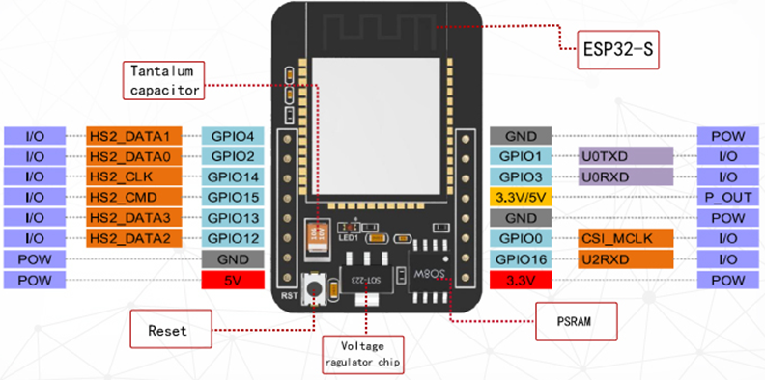

**ESP32-CAM pinout reference**

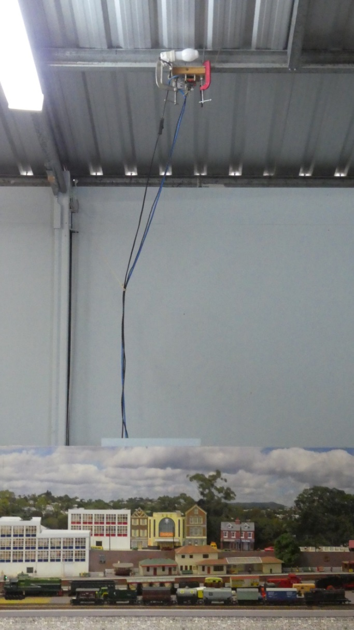

BCD **experimental** setup with incandescent light bulb and long powered USB